**Unit 2 Assignment Instructions – CIS164** 

*For the Unit 2 Assignment we will be writing our first Python script!*

*Please make sure to fully read each question to ensure that you answer each question per the requirement. Also, please ensure that all responses are in complete sentences, free of spelling and grammatical errors.*

**\*Unit 2 Grading Rubric (45 Points):**

|  |  |  |
| --- | --- | --- |
| **Assignment Requirements** | **Maximum Points** | **Points Earned** |
| 1. Hello World! | **0-20 Points** |  |
| 2. Interaction with Python | **0-25 Points** |  |
| **Points Deducted for Spelling or Grammatical Errors** | |  |
| **Total (Sum of All Points)** | |  |

**\*Directions for Submitting Your Assignment:**

Complete your assignment ensuring all questions are answered based on the assignment requirements. When the Unit 2 assignment is complete, please save your file in the following format, *“Lastname-Unit#.doc”* (Example: **Smith-Unit2.doc**). You may also utilize a Word Processing software such as LibreOffice for assignment completion. In this case the assignment may be saved in .odt format, (Example: **Smith-Unit2.odt**). Then when ready submit your file to the “**CIS 164 – Unit 2 Submit Assignment**” activity for grading.

**1. Hello World!**

1. After starting the PyCharm IDE. Select “Create New Project.” On the next screen, ensure that Python 3 is set as the ‘Interpreter’ for the project. Then under “Location” change the word “untitled” to “Unit2”. Then click the “Create” button.
2. Next, highlight your new project “Unit2” then right click. When you right click a menu will appear, from this menu select New->Python File. Then a dialog box will appear, in the “Name” field of the dialog box type “HelloWorld.py”.
3. Next within your “HelloWorld.py” file, type the following: print(“Hello World!”)
4. Then right click the file HellowWorld.py and choose “Run HelloWorld”. At the bottom of your IDE you should see a console output that shows the following:

Hello World!

Process finished with exit code 0

If you see that output, Congratulations! You just wrote your first Python script! Lastly, provide a screenshot showing the output from your first script and the code from your script.

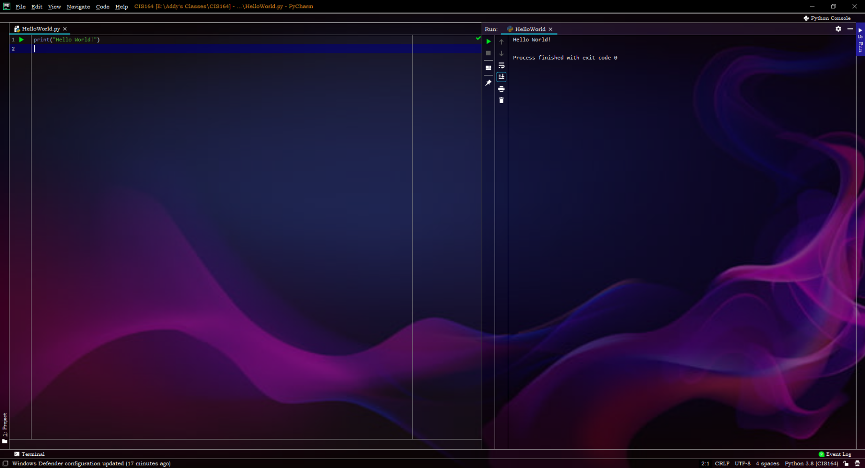

**2. Interaction with Python**

1. Highlight your project, “Unit2” then right click. When you right click a menu will appear, from this menu select New->Python File. Then a dialog box will appear, in the “Name” field of the dialog box type “FavoriteNumbers.py”.
2. Within your “FavoriteNumbers.py” file, you will need to receive input from a user to ask them their two favorite numbers. Then you will you need to add those numbers provided and provide the output to the user.
3. When completed, provide a screenshot showing the output from your script being run, as well as your code for your script.

